Identifying and Comparing Types of Coal
adapted from American Coal Foundation (www.teachcoal.org)
with additions from 2008-2009 TESSE Graduate Fellows from Penn State University (www.tinyurl.com/tessedissemination)

Overview
Students identify and compare four types of coal by examining hand samples and observing burning coal samples. The burning coal experiment can be conducted in the class or a video of the experiment can be shown to the students if the materials for that activity are not available.

Objectives
Students will:
- Examine four unidentified types of coal and document their observations about each.
- Observe the burning behavior (i.e., flame color, length of burning, speed of ignition) of the four samples.
- Draw conclusions about the identity of each coal specimen (based on the information presented initially along with what they observed about each sample)

National Science Education Standards (http://www.nap.edu/openbook.php?record_id=4962)
- Science as Inquiry, 5-8
  - Abilities necessary to do scientific inquiry
- Physical Science, 5-8
  - Properties of matter and changes in properties of matter
- Science in Personal and Social Perspective, 9-12
  - Natural resources
Materials Needed
- Hand specimens∗ of the peat, lignite, bituminous, and anthracite (they should be labeled 1 – 4)
- Coal ID worksheet
- Stopwatch
- A computer should be available to show the video of the burning coal samples performed by TESSE grad fellows

Lesson Procedure
- This activity should be conducted after some brief information about coal is introduced to the class. The Introduction to Coal PowerPoint presentation can be used as provided by the TESSE grad fellows. To gauge what they already know or do not know about coal, simply ask the students to tell you what they know about coal. You would then write down everything they say about coal on the blackboard for all to see. Next, generally begin by explaining to the students that there are four major categories (or ranks) of coal: (1) lignite, (2) subbituminous, (3) bituminous, and (4) anthracite. Although peat is not actually coal, it is a brownish-black organic matter from which the other categories of coal are formed. In this experiment, students will examine hand samples of peat, as well as lignite, bituminous, and anthracite coals (hand specimens can be ordered from Wards Natural Science website as previously mentioned). Review the following characteristics of each material that will be examined.
  - Peat: A brownish-black organic matter that looks very much like decayed wood, commonly used for peat moss (a garden mulch). Peat is not coal.
  - Lignite: A brownish-black coal with generally high moisture and ash content and the lowest carbon content and energy value.
  - Bituminous: A soft, intermediate grade of coal with carbon content and moisture between that of lignite and anthracite. It is the most common and widely used coal in the United States.
  - Anthracite: The hardest type of coal, consisting of nearly pure carbon. It has the highest heating value and the lowest moisture and ash content.

- Hand out the Brief Descriptions and Ranks of Coal and Peat (available at end of Lesson Plan) table for students to refer to during the activity. Discuss the answers to the questions below the table
  - What are the distinguishing characteristics or properties of coal?
  - What test(s) can you perform in order to distinguish between the different types of coal?
  - Do you see a trend that relates the rank to the percentage of carbon for each type of coal?
  - Do you see a trend that relates the heating value to the percentage of carbon for each type of coal?
  - Which rank(s) of coal would be best for energy production? or Which rank(s) of coal has the most stored energy?

- Give each student a Coal Identification Worksheet. Pass the numbered coal samples around the room, allowing each student to examine the samples and take note of any evidence of plant matter, color, hardness, and luster. Encourage students to be as descriptive as possible on their worksheet in an effort to distinguish the specimens from one another. In other words, calling each specimen "brownish-black" is not specific; noting that "specimen 1 is darker than specimen 2" is preferable. Ask the students if they can correctly identify each sample. Have them hypothesize about the identity of each specimen and write their hypothesis on the worksheet.

- Remind students that visual appearance is not the only distinguishing characteristic of the various ranks of coal. Heating value is another significant property. Show the Coal Burning Video, and tell students to document the speed of ignition and burning time of the samples on the second chart of the worksheet. Speed of ignition refers to the time it takes for the coal to ignite; while burning time refers to the time it takes for the specimen to stop burning once it’s ignited. Meanwhile, tell students to record the flame color and any other observations (e.g., the sample begins to smoke). The Coal Burning Video is provided to alleviate safety concerns and/or equipment limitations in your classroom. If you are using the Coal Burning Video, your students will not be able to detect an odor. From our experience in coal, a sulfur smell is generally detected when burning each sample.
- Have students work in pairs or small groups to consolidate and discuss their observations. Are they able to identify the specimens? Allow them to change their hypotheses about the identity of each specimen if they want to. Conduct a class vote about each specimen, asking students which type of coal they think it is. Have them discuss as a class their reasons for reaching this conclusion.

- Reveal the identity of each sample. Explain that higher ranks of coal are literally and physically harder. As coal rank increases, the slower the coal ignites (i.e., higher rank coals take longer to ignite than lower rank coals, lower rank coals ignite faster than higher rank coals) and the longer the coal burns once ignited (i.e., higher rank coals burn for a longer period of time than lower rank coals once ignited).

Assessment
Have students prepare a paragraph summary of the experiment. Did their hypotheses change after they observed the samples being burned? At what point in the experiment did they become certain of the identity of each specimen?

Extension
Encourage students to find out more about where each type of coal can be found in the United States. They can begin with the Coal Reserves map provided by TESSE. Have them follow up by finding out how much of a specific rank of coal has been mined in the past year and where. Students can also consult the database of coal power plants in the U.S. at the National Energy Technology Laboratory’s website (http://www.netl.doe.gov/energy-analyses/hold/technology.html) along with Carbon Monitoring for Action’s (CARMA) blog for a Google Earth file that contains real-time information (i.e., location, rank of dirty vs. clean based on fuel source, and operating power capacity) about various power plants within the world (http://carma.org/blog/earth). Students can also refer to the plots at the end of this Lesson Plan to see how chemical components (namely carbon, oxygen, hydrogen, sulfur and nitrogen) and calorific value change with changes in coal rank.
Brief Descriptions and Ranks of Coal and Peat

Peat | Lignite | Subbituminous | Bituminous | Anthracite
<55% Carbon | 55-61.5% Carbon | 61.5-64% Carbon | 64-86% Carbon | >86% Carbon
4500 BTU/lb | 7000 BTU/lb | 9,300 BTU/lb | 11,250 to  14,350 BTU/lb | 13,600 BTU/lb
A brownish-black organic matter that looks very much like decayed wood. It is commonly used for peat moss or garden mulch.  Peat is not coal. | A brownish-black coal with generally high moisture and ash content and the lowest carbon content and energy value. | A dull black coal. It has a littler higher energy value than lignite when it burns. | A soft, intermediate grade of coal with carbon content and moisture between that of lignite and anthracite. It is the most common and widely used coal in the United States. | The hardest type of coal, consisting of nearly pure carbon. It has the highest heating value and the lowest moisture and ash content.
Pre-Cursor to Coal  No Rank | Lowest Rank | Low-Middle Rank | High-Middle Rank | Highest Rank

Some initial questions to discuss with the students include:
- What are the distinguishing characteristics or properties of coal?
- What test(s) can you perform in order to distinguish between the different types of coal?
- Do you see a trend that relates the rank to the percentage of carbon for each type of coal?
- Do you see a trend that relates the heating value to the percentage of carbon for each type of coal?
- Which rank(s) of coal would be best for energy production? or Which rank(s) of coal has the most stored energy?

References: 1) American Coal Foundation (www.teachcoal.org); 2) Coal in Pennsylvania (http://www.dcnr.state.pa.us/topogeo/education/coal/es7.pdf)
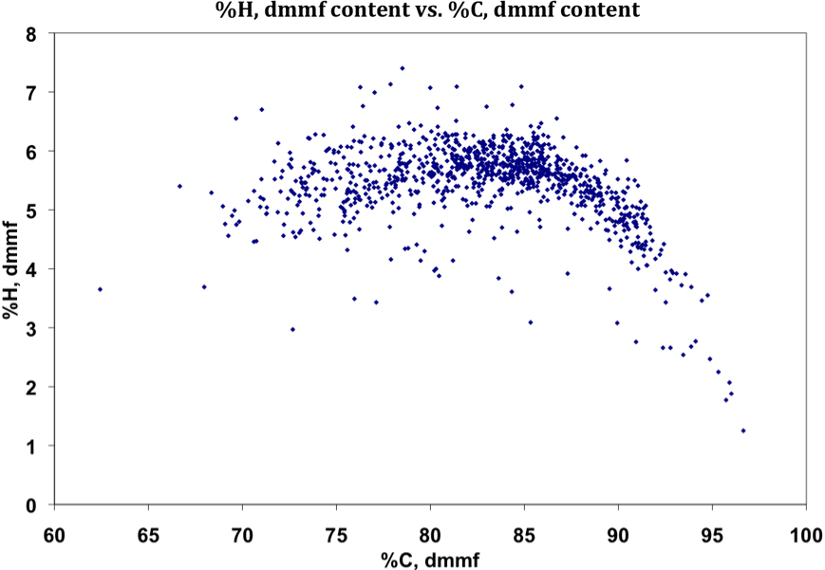
When plotted correctly, this chart reveals the path of coalification in which lower rank coals plot to the left with rank of coals increasing to the right. Thus, Seyler’s chart is essentially known as a classification system because of this plotting trend. From Mitchell’s “Coal Classifications”, Seyler’s chart later included plots of volatile matter and calorific value superimposed on the original graph.

This figure was generated using data from the Penn State Coal Sample Bank (http://www.energy.psu.edu/copl/doesb.html) and the Argonne Premium Coal Database (http://www.anl.gov/PCS/report/part2.html).

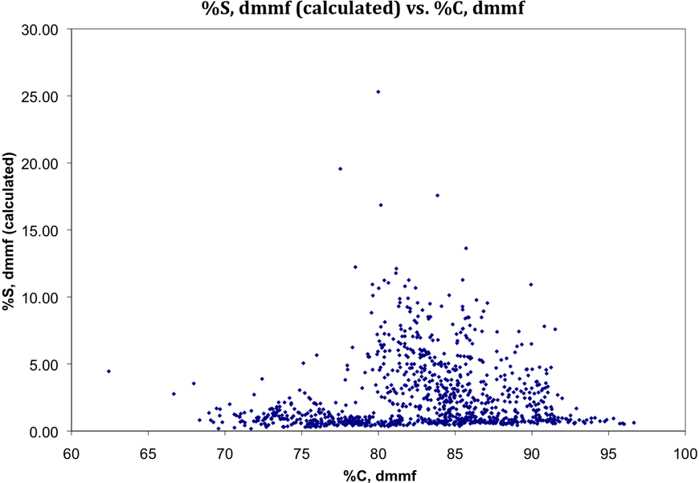
This figure is showing %S, dmmf (calculated) vs. %C, dmmf. There generally is no trend between sulfur and rank; however, coals with high carbon contents (greater than ~90%C) and low carbon contents (less than ~75%C) have the least amount of sulfur present.

This figure was generated using data from the Penn State Coal Sample Bank (http://www.energy.psu.edu/copl/doesb.html) and the Argonne Premium Coal Database (http://www.anl.gov/PCS/report/part2.html).

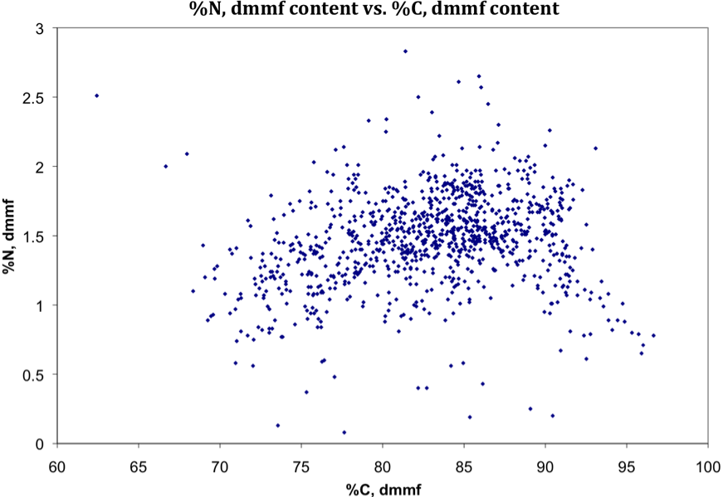
This figure represents the %N, dmmf content vs. %C, dmmf content from both databases. There does not appear to be a distinct trend so the scattering of data may indicate that there is no correlation between the two elements. Nonetheless, from Mitchell’s chapter on “Coal Classifications”, the variability of nitrogen concentration makes it less desirable to use as a rank parameter so this figure may not be a good indication of rank after all even with observable correlation.

This figure was generated using data from the Penn State Coal Sample Bank (http://www.energy.psu.edu/copl/doesb.html) and the Argonne Premium Coal Database (http://www.anl.gov/PCS/report/part2.html).

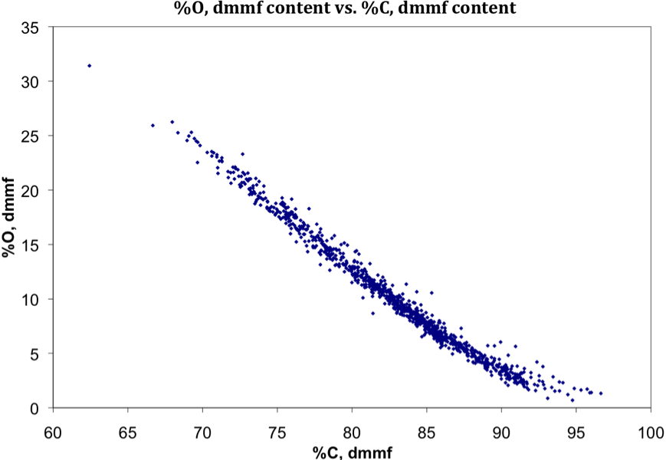
This figure represents the %O, dmmf content vs. %C, dmmf content from both databases.
Similar to the Seyler’s chart, coal rank increases as %O decreases and %C increases; thus, the coal rank is increasing from left to right in the figure.

Main point to take from graph: rank increases from left to right (i.e., rank increases as %O content decreases and %C content increases)

This figure was generated using data from the Penn State Coal Sample Bank (http://www.energy.psu.edu/copl/doesb.html) and the Argonne Premium Coal Database (http://www.anl.gov/PCS/report/part2.html).

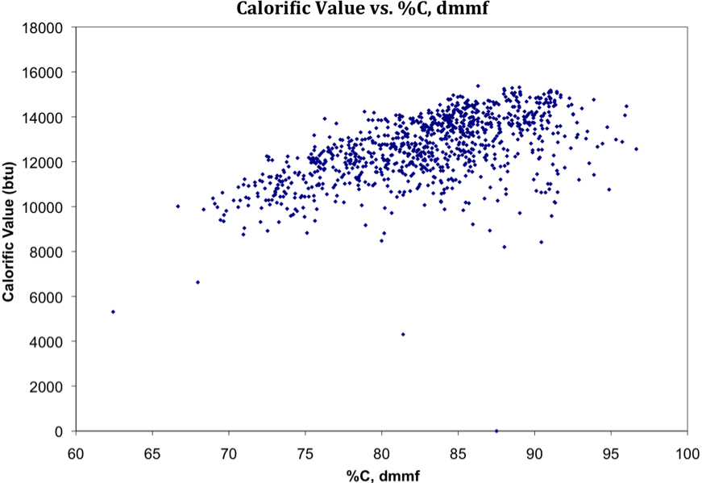
This figure shows calorific value vs. %C, dmmf. Since %C, dmmf is a good parameter of rank, this figure shows that calorific value increases with increasing rank (i.e., calorific value increases as %C, dmmf increases).

This figure was generated using data from the Penn State Coal Sample Bank (http://www.energy.psu.edu/copl/doesb.html) and the Argonne Premium Coal Database (http://www.anl.gov/PCS/report/part2.html).

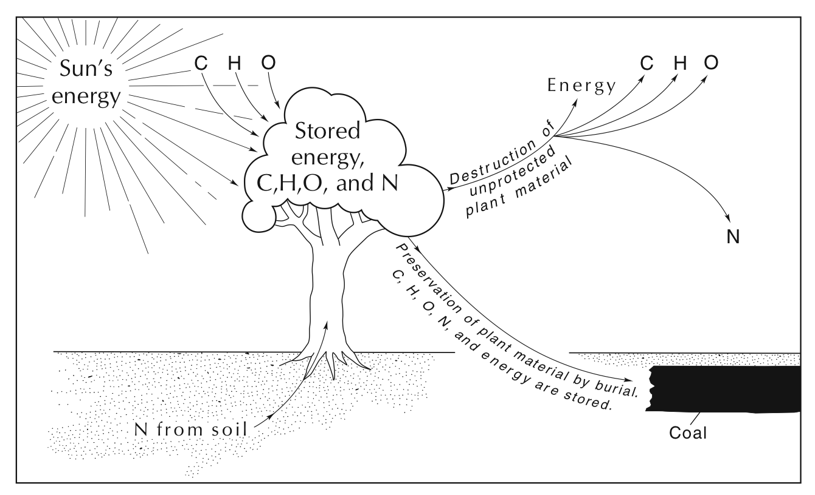
This figure shows the source of the chemical elements and energy stored in coal.
C=carbon, H=hydrogen, O=oxygen, N=nitrogen. - from Coal in Pennylvania (2002)

 hand specimens can be ordered from Ward’s Natural Science website (http://wardsci.com)

