Mountain Building: Alps v. Himalaya

Below are two transects across active mountain ranges in the French Alps and the Himalayan/Tibetan Plateau.

Location Maps:

ALPS: (profile extends from 6°E, 47.5°N to 9°E, 45°N)

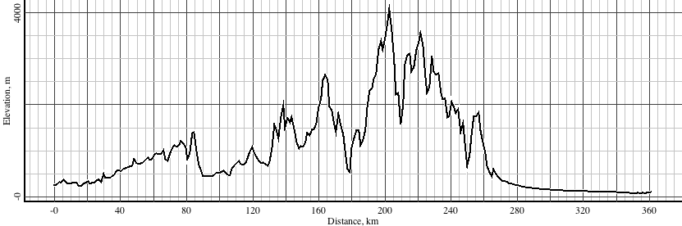

HIMALAYA/TIBET: (profile extends from 85°E, 26°N to 94°E, 41°N)

