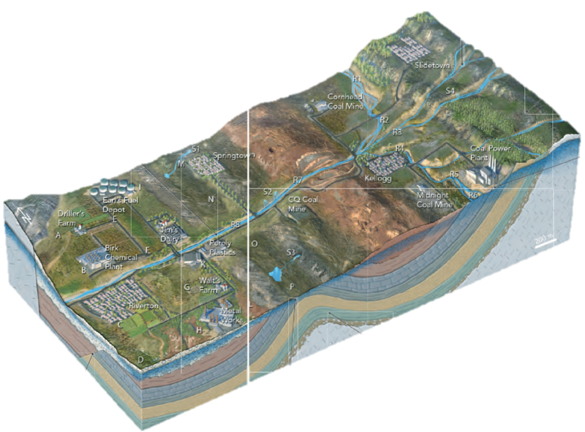

E

W

S

Figure 3- 3D Map of Springfield USA

In this figure, you will see a 3 dimensional map of Springfield, USA. The region contains a series of ridges to the east, and a broad, gentle valye to the west. Small towns are scattered across the ridges and valleys. There are also farms, a dairy, and several industrials sites labeled on the map.

Based on shallow drilling geologists are able to know that the water table (the blue shading) follows patterns in the topography- it is higher under ridges than valleys. Overall, the water table slopes east to west, parallel to the regional slope of the land.

N

The *Black River-* named for its dark, cloudy color. Flows north to south year round, even when not raining. The valley slopes into the river.

The highest part of the region is made of granite and sedimentary rocks. It receives quite a bit of rain and snow during the year. Several steams begin here and flow west towards the lowlands of the valley.

A coal-burning power plant was built over the “Sinkerton limestone,” a permeable rock with many sinkholes, caves and karst topography. Because of this permeability, the power plant has trouble keeping water in the ponds they have for disposing of wastewater from the processing of the coal.

Geologists have studied the topography of the area to map the stratigraphy (Figure 2) of the area, and determined the rocks under Springfield are a broad syncline and anticline.

One north-south valley is called “Coal Mine Valley”- it has several large coal mines and a coal-burning, electrical-generating plant. (Non-confirmed) rumors exist that there was a chemical spill at one of the mines that was not reported. Also, coal mine and power plant activity causes fine coal dust to be moved around by wind and water into the small streams.

Geologists have used drills and gravity surveys to show that under the valley is weakly cemented sand and gravel and that there is a normal fault underneath the gravel.

The north-south ridge is made of sandstone (lower sandstone). Clear, freshwater springs exit the sandstone into small streams.