Cabaiguan, Cuba
2013/113/17:38:42
Image: 30870
N

Atlantic Ocean
Las Grimas Prison
Maximo Village

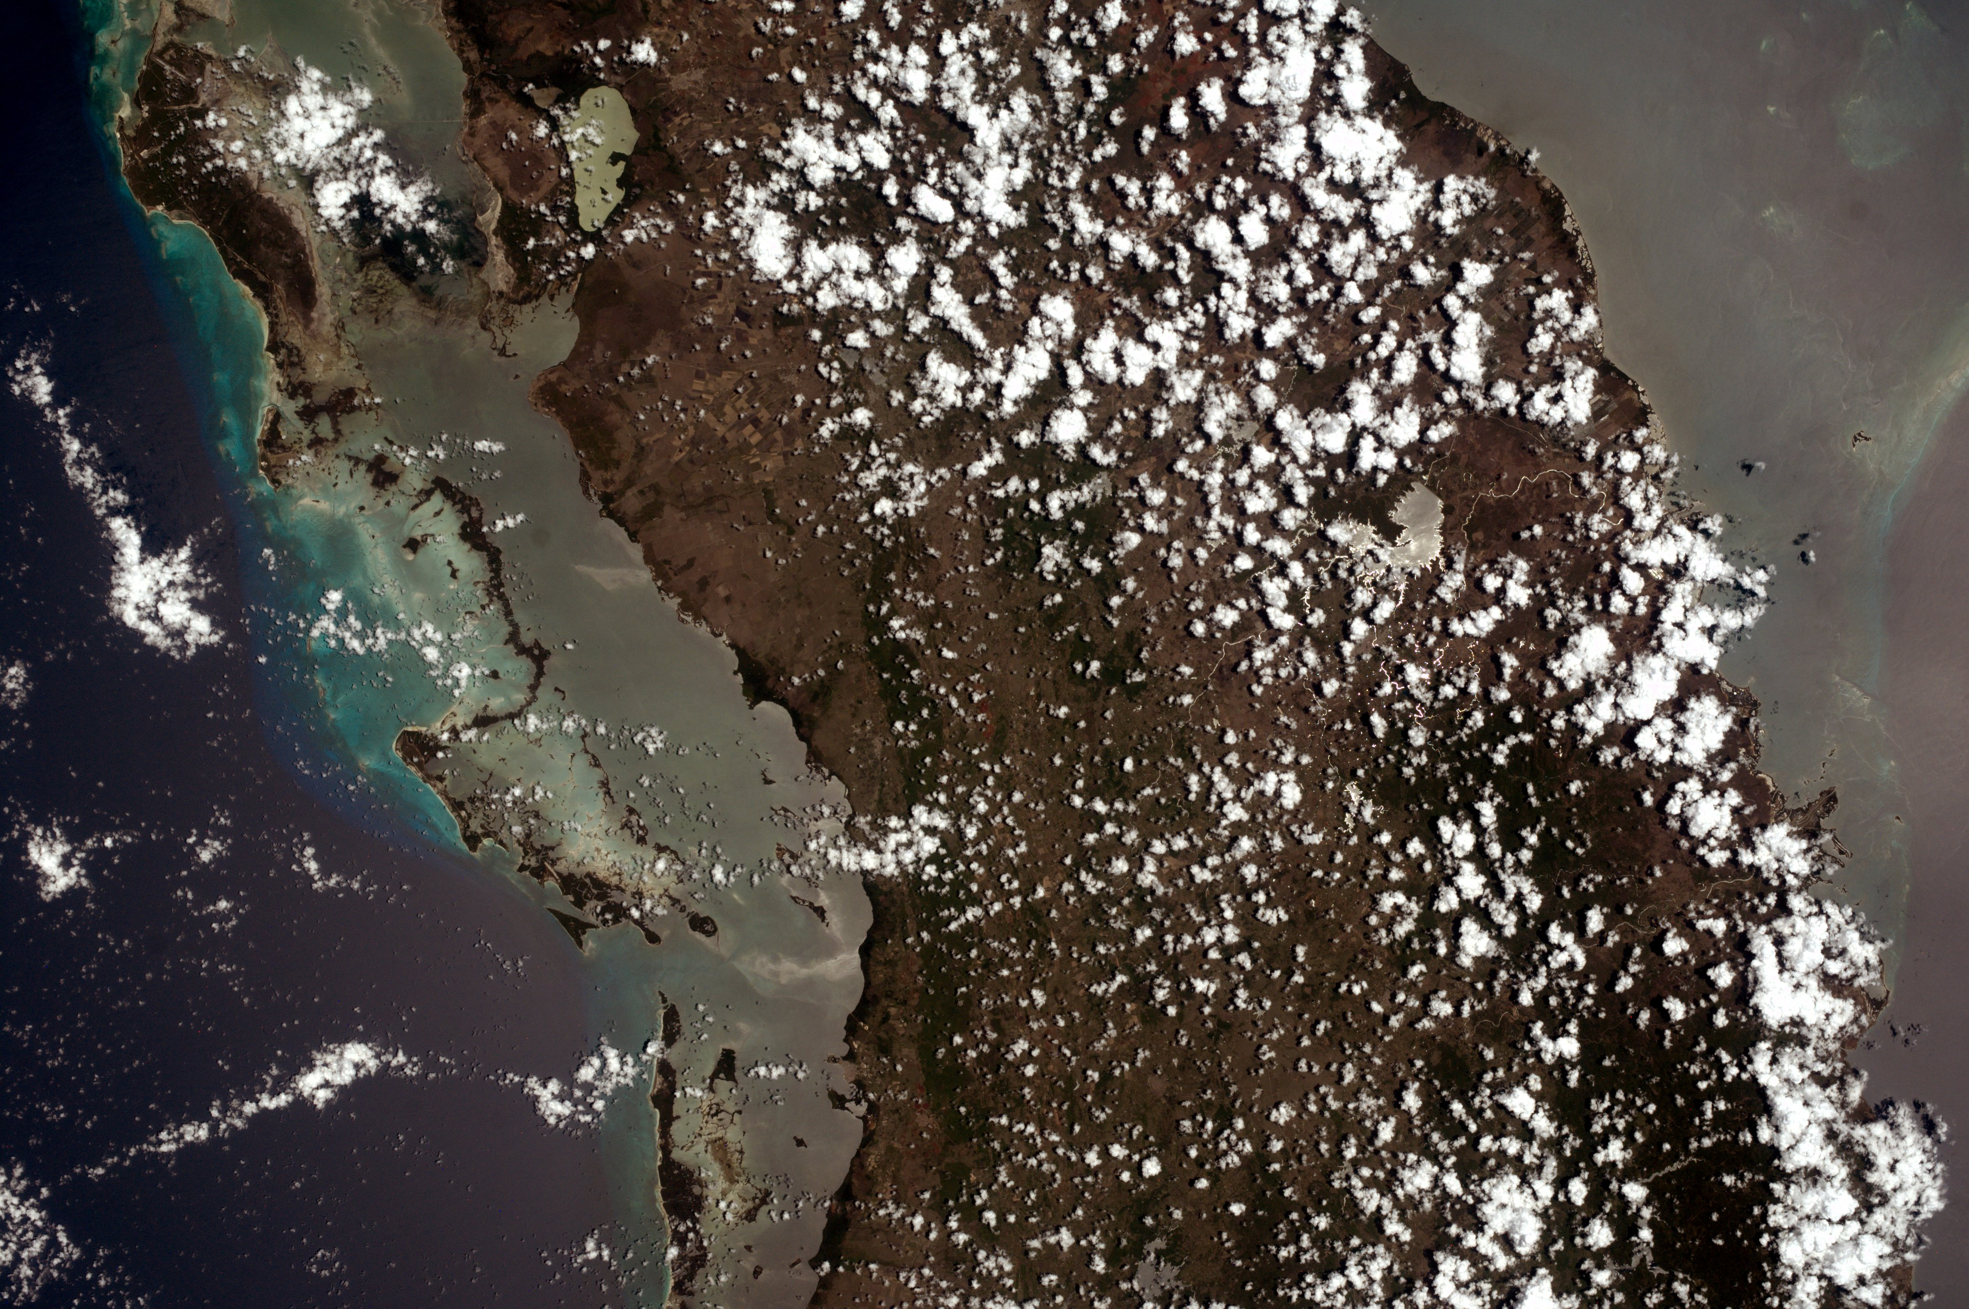
My intriguing EarthKam photo was taken in in the spring, 2013 mission and its image number is 30870. The latitude of this picture taken in Cuba is 22°24'40. 24"N and the Longitude is 79°10'58. 76"W. The original latitude and longitude was 22.22° N, 79.36° W, which was very close. The distance between those coordinates are 17.84 miles. In UTC, my photograph was taken on April 29, or 2013/113/17:38:42 p.m. In local time in Cuba, that would be 5:38:42 p.m. The ETC would be 1:38:42 p.m. There were many unique features in the picture but one that really stood out was the National Park, Caguanes. It looked interesting because when I clicked on it in Google earth, fascinating pictures of landforms and descriptions of them in the park looked amazing. I chose this picture because I have always wanted to learn about Cuba. Additionally, I have always been interested in why no US citizens can go there. In conclusion, I have learned a lot from this project such as latitude and longitude, as well as there are satellites in space that can take high-resolution pictures of Earth.
Yaguajay-(city)
Laguna de la leche
Spring Port Airport
National Park - Caguanes
Altocumulus Clouds
Cabaiguan-(city)

Sarah Student
8-1 honors

