Evaluating Visualizations: An Example for Teachers
From Earth Science By Design Handbook for Professional Developers (2006), available at: http://www.esbd.org/resources/ESBDBOOK.pdf

When evaluating the effectiveness of a visualization, consider both its basic design and your intended instructional use. Use these questions to guide your evaluation.

NOTE: the visualization evaluated here is Crustal Age of the World’s Oceans

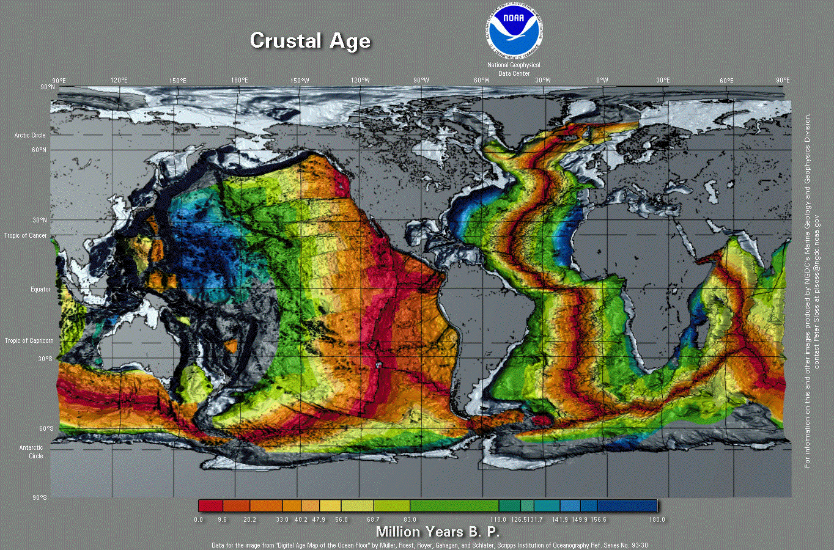
(color image available at: http://www.ngdc.noaa.gov/mgg/image/WorldCrustalAge.gif)

Grade level:
For what grade level is this visualization appropriate?
Grade 6, 7, or 8

Instructional role:
What big and subsidiary ideas in Earth science will this visualization help students understand?
Possible concepts this visualization may help uncover include:
  - The age of the ocean floor varies from place to place
  - There are general patterns in the distribution of the age of the ocean floor
  - The distribution of the age of the ocean floor provides compelling evidence that plates move relative to one another
  - Plates move at varying rates and in varying directions

Accuracy:
Is this visualization scientifically accurate? Which person or agency created this visualization? What is the underlying data, and how was it collected and processed to create this visualization?
It was produced by NOAA and appears to be scientifically accurate. The data comes from Scripps Institute of Oceanography.

Background knowledge:
What content knowledge is needed to understand this visualization? Are preparatory activities or scaffolding needed to use this visualization effectively? If so, how can these be provided to students?
The background content needed to understand this visualization depends upon what the user is expected to “read” from the image. At the introductory level, users need to be able to distinguish landmasses from ocean floor. As they describe and discuss patterns, it would also be helpful to have general knowledge of the locations of continents and major oceans. At the more advanced level, if students are expected to gather evidence from the image to support the notion that plates move relative to one another, then they would need to have a prior understanding of plates and plate boundaries.

Embedded conventions:
What visual conventions does this visualization use that students might not understand or that might lead to confusion?
- Scale: Is the scale clearly indicated? Is there any exaggeration of scale? For example, is the vertical dimension exaggerated with respect to the horizontal dimension?
  - There is no distance scale, but latitude and longitude lines are appropriately displayed.
- Legend and labels: Are they present, clear, and adequate?
  - Students may need to be told that B.P. stands for before present.
- Projection: Are there aspects of the projection (such as distortion of area) that need to be explained?
  - Not really. This particular projection does not appear to produce extreme distortions of the landmasses.
- Color: Is it clear what the colors in the visualization represent? Are the colors misleading or confusing?
  - The colors in the image are “false.” The ocean floor does not look like this. Students might need help understanding that the colors represent age and not elevation.
- Time and date: Is the time and date information provided adequate to understand the visualization?
  - Yes.

Misconceptions:
Might this visualization inadvertently introduce misconceptions or misunderstandings? If so, how can you provide additional information to guard against this misunderstanding?
Because the landmasses are gray and the ocean floor is vividly colored, the eye is often drawn first to the ocean floor. This makes it difficult for students to orient to the image. Call their attention specifically to the continental landmasses. Making sure students can locate North and South America, and perhaps Africa will help make the image less confusing.

