How old is the Earth?
An investigation into Geological Time Scales

Teacher Information
In this activity students will make pre-activity claims in order to assess their prior knowledge of the age of Earth and the things that exist on it. They will collect evidence from their created time line in order to decide if their claims are proven or disproven.
This activity is designed as a set up to talk about Plate Tectonics. Many students have misconceptions, or in some cases just misunderstandings, regarding the age of Earth and length of time things took to occur on Earth. Examples of this would be believing dinosaurs and humans co-existed, or that the Earth is only a few thousand years old.
This is designed for students who have already been exposed to the Claims-Evidence-Reasoning format and utilizes it as not just a conclusion, but also as a hypothesis. Reasoning has been intentionally left out as this is an introduction piece and students are not expected to have background knowledge of Plate Tectonics.
Cross-curricular concepts
- Ratios and proportions
- Ruler use
- Common Core- Science Literacy (Claims and Evidence)
Materials
- Adding machine tape (5 meters per group)
- Meter sticks and 12 inch rulers with metric measurement (1 each per group minimum)
- 4 colors of highlighter (1 set per group)
- Pencils (per student)
- Activity sheets (per student)
Resources:
- http://www.geology.wisc.edu/~museum/hughes/GeoTimeScale1.html
- Cognition Science Instruction- The 21st Century Center for Research and Development in Cognition and Science Instruction. http://21pstem.org/
- PA Department of Conservation and Natural Resources: Geology of Pennsylvania. Geological Time Scale. http://www.dcnr.state.pa.us/topogeo/field/
- http://www.arizonahandbook.com/index.html (Figure 1 Image)

Name: _______________________________________________ Date: ___________ Period:______
8th Grade Science : How old is the Earth?
Present Day
Introduction: We say the Earth is “very old,” but just how old is the Earth? What evidence can scientists use to

Instructions:
- Make sure your have filled in all claims in the first column of your data sheet.
- Measure out 5m of adding machine tape. Using your meter stick, draw a line through the middle of your tape vertically with an arrow pointing to the top of the column.
- As this is a map we will need a scale. 5.0m=1,000,000,000.0 years (1 billion years.)
Do the Math!
  - 1.0m= ______________________ years
  - 1.0cm= _____________________ years
  - 1.0mm= ____________________ years
- Label your scale in the bottom left corner of your map, where 1.0cm= ___________ years
- Label the top of your paper “Present Day.”
- Starting at the top, mark horizontal lines at 1 billion year increments down the paper.
- In the table below, calculate the distance on the timeline for each significant event.
- Using the table below, mark off significant events in Earth’s history. All times start from present day
Table 1- Significant events in Earth’s history
Event | Time | Distance on timeline | Event | Time | Distance on timeline
Water appears on Earth’s surface | 4000 million years ago |  | Trees growing in Pennsylvania | 359 million years ago
Continental crust of Pennsylvania forming | ~3800 million years ago |  | First dinosaurs | 245 million years ago
Earliest bacteria-like life | 3500 million years ago |  | Atlantic Ocean forming | 200 million years ago
First land plants | 450 million years ago |  | First flowers appear | 150 million years ago
Pennsylvania under water | 444 million years ago |  | Rocky Mountains form | 144 million years ago
First land animals | 420 million years ago |  | Dinosaurs become extinct | 66 million years ago
First insects | 400 million years ago |  | Modern Humans appear | 40,000 years ago

- Using your highlighter, create a key, and shade in a line on left side of the paper to mark off the major Era’s in Earth’s history as listed in the table below.
Table 2- Age of Era’s in Earth’s history
Name of Era | Color on timeline | Start date of Era | Distance on timeline | End date of Era | Distance on timeline
Cenozoic |  | 66 million years ago |  | Present time
Mesozoic |  | 200 million years ago |  | 66 million years ago
Paleozoic |  | 542 million years ago |  | 251 million years ago
Precambrian |  | 4600 million years ago |  | 542 million years ago

- Extension: Look at the cross section of the Grand Canyon attached. Can you compare it to your timeline?
________________________________________________________________________________________________________________________________________________________________________________________________________________________________________________________________________________________________________________________________________________________________________________________
- Revisit your data sheet after completing your timeline. What evidence on the timeline can you use to either support or refute your claim?

Figure 1- Geological Cross Section of the Grand Canyon
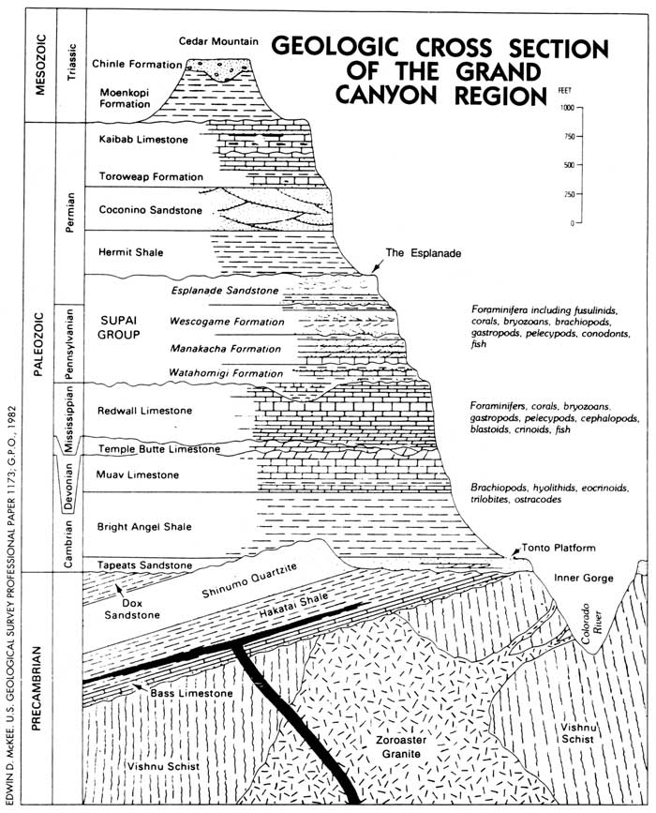
http://www.arizonahandbook.com/GC_river2.htm
Answer Key:
- As this is a map we will need a scale. 5.0m=1,000,000,000.0 years (1 billion years.)
Do the Math!
  - 1.0m=1 billion years
  - 1.0cm= 10 million years
  - 1.0mm= 1 million years
- Label your scale in the bottom left corner of your map, where 1.0cm= 100 million years
Event | Time | Distance on timeline | Event | Time | Distance on timeline
Water appears on Earth’s surface | 4000 million years ago | 4m | Trees growing in Pennsylvania | 359 million years ago | 35.9cm
Continental crust of Pennsylvania forming | ~3800 million years ago | 3.8m | First dinosaurs | 245 million years ago | 24.5cm
Earliest bacteria-like life | 3500 million years ago | 3.5m | Atlantic Ocean forming | 200 million years ago | 20.0cm
First land plants | 450 million years ago | 45.0cm | First flowers appear | 150 million years ago | 15.0cm
Pennsylvania under water | 444 million years ago | 44.4cm | Rocky Mountains form | 144 million years ago | 14.4cm
First land animals | 420 million years ago | 42.0cm | Dinosaurs become extinct | 66 million years ago | 6.6cm
First insects | 400 million years ago | 40.0m | Modern Humans appear | 40,000 years ago | 0.4cm

Name of Era | Color on timeline | Start date of Era | Distance on timeline | End date of Era | Distance on timeline
Cenozoic | (group choice) | 66 million years ago | 6.6cm | Present time | 0cm
Mesozoic |  | 200 million years ago | 20cm | 66 million years ago | 6.6cm
Paleozoic |  | 542 million years ago | 54.2cm | 251 million years ago | 20cm
Precambrian |  | 4600 million years ago | 4.6m | 542 million years ago | 54.2cm

