Mapping Watersheds
(Modified from “A River Runs Through It” from http://www.esri.com/geoinquiries)

Learning Objectives: Students will be able to determine what factors impact the geographic spatial extent of a watershed.

Standard Assessed:
- PA Science Standards:
  - 3.3.6.A1. Recognize and interpret various mapping representations of Earth’s common features.
  - 3.3.6.A4. Describe how water on earth cycles in different forms and in different locations, including underground and in the atmosphere.
  - 3.3.7.A6. MODELS/SCALES- Locate significant geological structures using various mapping representations.
  - 4.2.6.A – Identify the five major watersheds of Pennsylvania.
  - 4.2.7.A – Explain how water enters, moves through and leaves a watershed.
    - Explain the concept of stream order.
    - Describe factors that affect the flow and quality within a watershed
  - 4.2.10 – Examine the interactions between abiotic and biotic factors with in a watershed
    - Describe how topography influences the flow of water in a watershed.
- NGSS Standards:
  - MS-ESS2-4: Global movements of water and its changes in form are propelled by sunlight and gravity.
  - MS-ESS2.C: Water continually cycles among land, ocean, and atmosphere via transpiration, evaporation, condensation and crystallization, and precipitation, as well as downhill flows on land.

Prep Time: Varying based on desire to modify activity to fit needs of students. Activity can be modified to fit the needs of the classroom. Teachers should always try activities before administering to students

Time to Complete: 1-2 (45 minute) class periods, depending on computer skills of students and freedom given to students to explore the program

Materials: Computer & internet access for student/pairs of students
ArcGIS “A River Runs Through It” website: http://bit.ly/earthgeoinquiry10
Reflection Questions in hand out

Description: In this activity students will explore watersheds in their local area, as well as those pertinent to discussion of the human impact on the watersheds in their own area and globally in areas with water problems. This activity will use the ArcGIS activity “A River Runs Through It” to trace areas that feed into rivers, and examine the physical geology of the area that contribute to this watershed morphology. Though any watershed can be used, the examples in this activity focus on the watersheds involving the Delaware, Susquehanna, Colorado and Mississippi Rivers in the United States and the city of Toowoomba in Australia’s Queensland Providence in support of the book, “The Big Thirst: The Secret Life and Turbulent Future of Water” by Charles Fishman. This activity can also be completed with students that have not read “The Big Thirst.”

Part 1: Your Watershed- Where does your water go?
- Open the URL for ArcGIS “A River Runs Through It:” http://bit.ly/earthgeoinquiry10. This will open to a map of the United States.
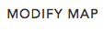
- In the top right corner, click on then “new map.”
- Under , next to “Measure” type the address of your school into the search box.
- Find the largest body of water near your school. Write it here: ________________________________
- Follow that body of water to where it flows into another, larger body of water. Continue until you reach a bay/sea/ocean/lake. Fill in the chart below, you may not need all columns. At the end, fill in the level, with the bay/sea/ocean as #1:

Location: (SAMPLE) Northeast Philadelphia
Level Name of body of water
3 | Poquessing Creek
2 | Delaware River
1 | Delaware Bay

Location: _________________________________________________________________________________
Level Name of body of water

Hint: River names will be found in BLUE on the maps. You may need to zoom in and out to find the names (i.e. when I was trying State College, the Susquehanna name didn’t show up until followed into Harrisburg, zooming out sooner would have shown me that more easily.)

Part 2: How are watersheds shaped?
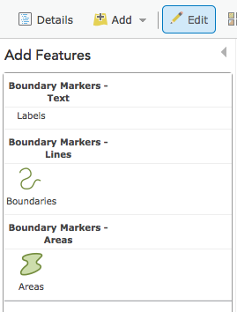
- Open the URL for ArcGIS “A River Runs Through It:” http://bit.ly/earthgeoinquiry10. This will open to a map of the United States. Make sure you re-enter the link to see the appropriate map set up.

- In the top right corner, click on then “new map.” You should see a large USA map.

- In the gray menu bar at the top right, click “Edit” as shown to the right, then, click “Areas

- Use the “Draw” tool to trace around the outside of the Mississippi River Watershed. Include all tributaries you can see that connect to the Mississippi River, like below. (Hint: You will need to make your browser as large as possible to make this work. Clearly, it does not need to be perfect.)

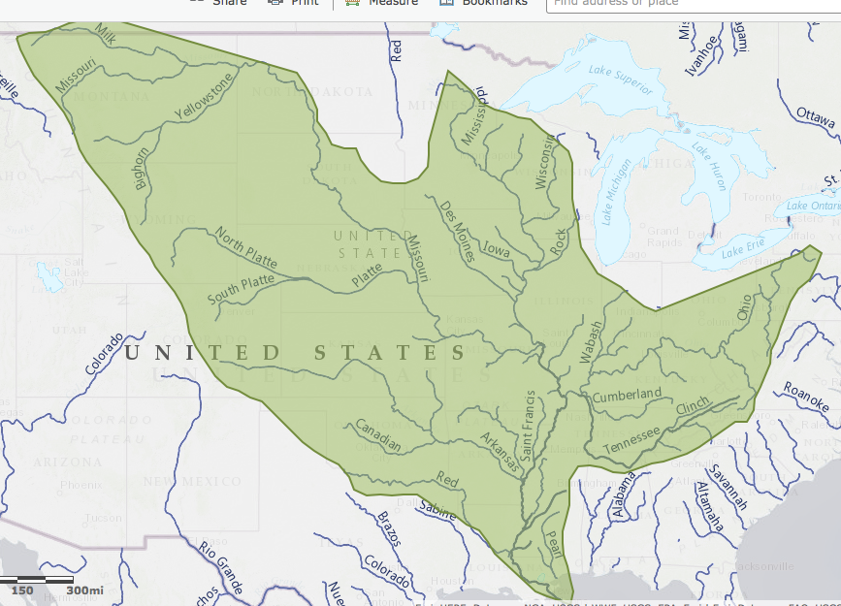

- Repeat steps 3 and 4 for the Colorado and Columbia River.
- Zoom in 1-2 clicks. This will allow you to see the actual watershed boundaries.
Reflection Question: How accurate were you? What areas did you struggle to match, why do you think this is?

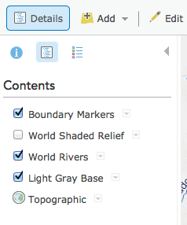
- Under “Details,” click on the matching white box with blue text icon. Make sure you see “Topographic” and unclick “Light Gray Base.” This will enable you to see the topographic features of the area.

Question: Examining the areas around the Mississippi, Colorado and Columbia Rivers, what affects the boundaries of a watershed? What evidence do you observe that can support this claim? What reasoning connects your evidence to your claim?

Challenge: Can you trace your own watershed where your school is located? What defines its boundaries?
Part 3: How do watersheds effect a city?

- Open the URL for ArcGIS “A River Runs Through It:” http://bit.ly/earthgeoinquiry10. This will open to a map of the United States. Make sure you re-enter the link to see the appropriate map set up.

- In the top right corner, click on then “new map.” You should see a large USA map.

- Under, next to “Measure” type in “Toowoomba, Queensland, Australia,” the town suffering drought in The Big Thirst.

- Using the same methods as you did to find your own watershed, and tracing the areas of the Mississippi, Colorado and Columbia, find the watershed to which Toowoomba belongs. You may need to zoom in and out.
Question: How does Toowoomba’s location appear to impact its watershed? What evidence do you observe that can support this claim? What reasoning connects your evidence to your claim?

Question: How might Toowoomba’s watershed impact its drought conditions? What evidence do you observe that can support this claim? What reasoning connects your evidence to your claim? (You may need to refer to The Big Thirst for more details, Chapter 6.)

