Southern Andes
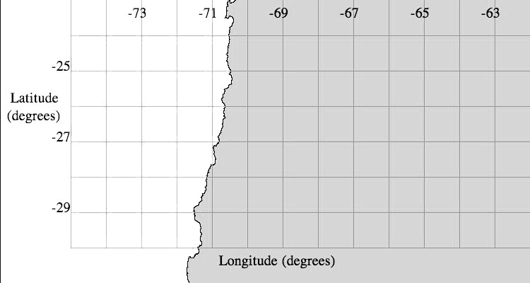
Map 1. Map view (plan view) of the Southern Andes area for plotting earthquake and volcano locations. Land surface is colored gray and ocean is colored white.

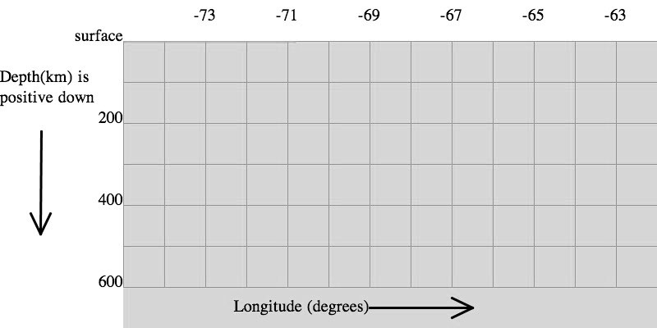
Cross-section 1. Cross-section view of the Southern Andes area. Note the different axis—the y-axis is now depth below the surface, instead of latitude.

Aleutians
Longitude (degrees)
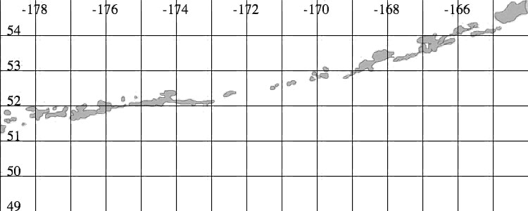
Latitude (degrees)
Map 2. Map view of the Aleutians area for plotting earthquake and volcano locations.
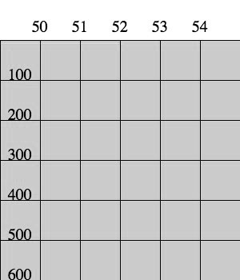
Depth (km)
Latitude (degrees)

Cross-section 2. Cross-section view of the Aleutians area.
Fiji
Longitude (degrees)
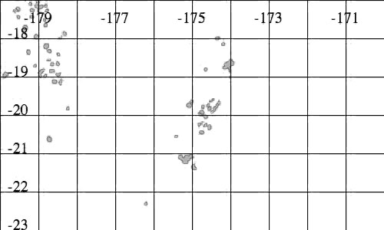
Latitude (degrees)
Map 3. Map view of the Fiji area for plotting earthquake and volcano locations.
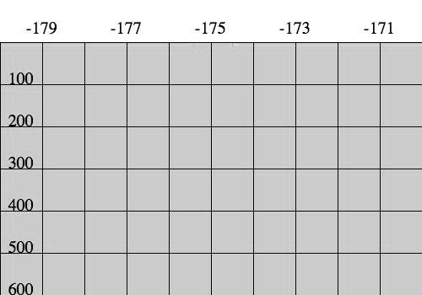
Depth (km)
Longitude (degrees)

Cross-section 3. Cross-section view of the Fiji area.
Indonesia
Longitude (degrees)
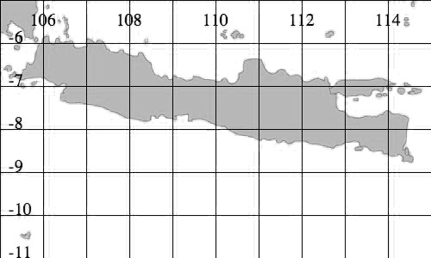
Latitude (degrees)
Map 4. Map view of the Indonesia area for plotting earthquake and volcano locations.
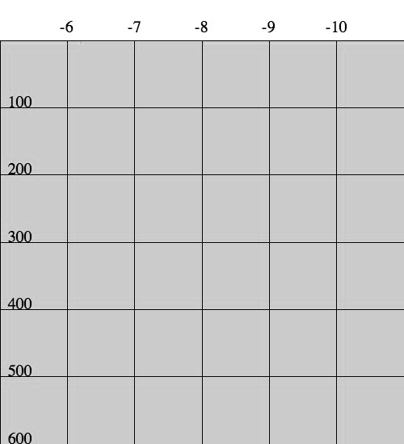
Latitude (degrees)
Depth (km)

Cross-section 4. Cross-section view of the Indonesia area.
Kuril
Longitude (degrees)
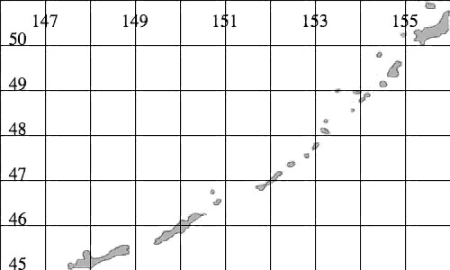
Latitude (degrees)
Map 5. Map view of the Kuril area for plotting earthquake and volcano locations.
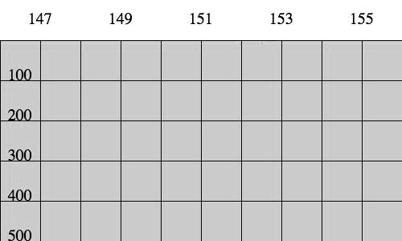
Longitude (degrees)
Depth (km)

Cross-section 5. Cross-section view of the Indonesia area.
Lesser Antilles
Longitude (degrees)
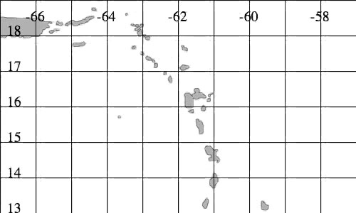
Latitude (degrees)
Map 6. Map view of the Lesser Antilles area for plotting earthquake and volcano locations.

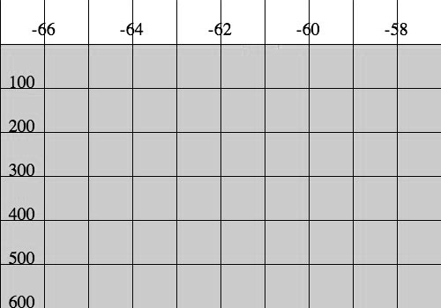
Depth (km)
Longitude (degrees)

Cross-section 6. Cross-section view of the Lesser Antilles area.

