Tectonic Geomorphology: Weathering and Erosion

Developed by Jenna Ellis, Steve McAninch and Heath Stout
This activity was designed for students in central Pennsylvania, but can certainly be adapted.
This activity helps students integrate observations of geology and topography, and then to contextualize modern topography in terms of erosion processes and hence rock strength.
Note that many of the days are viable as stand-alone activities, and do not require the full unit.
Days 1, 2 and 6 make a nice grouping in cases where students are familiar with plate tectonics.
Days 3 and 4 are a version of the tombstone activity found elsewhere in the PAESTA Classroom.
Days 7-10 can be adapted to your own local context.

Overall Learning Goals for Students:
(At the close of this unit, students should be able to…)
- Predict the relative importance of physical and chemical weathering on local rock types (sandstone, limestone, shale).
- Predict the regional topographic morphology on the basis of rock type
- Predict regional stream and/or groundwater pH on the basis of rock type
- Identify potential effects of natural and anthropogenic influences on stream and/or groundwater pH
- Predict the geological and tectonic future of central Pennsylvania based on relationship between rock types and tectonic processes

Schedule of Classes, Activities and Events
Day 1 Review rocks versus minerals; Sedimentary rocks of central Pennsylvania
Day 2 Physical and chemical weathering; Erosion and deposition
Day 3 Tombstone project (data gathering)
Day 4 Tombstone project (data reporting)
Day 5 Tectonics – rock types and mountain building
Day 6 Tectonics – rock types and mountain building in Pennsylvania
Day 7 Field trip to Spring Creek
Day 8 pH of rain and ground water; effect of rock type
Day 9 Final project preparation
Day 10 Final project preparation; post-unit assessment

Day 1 Review rocks versus minerals; Sedimentary rocks of central Pennsylvania
Activity 1 – Students (10 minutes)
- Form 3-4 person student teams; each team receives a sample of rock or mineral
- Groups articulate the differences between a rock and a mineral (from previous knowledge), and decide which sample type they have received
- Teams hypothesize their ideas/reasons for their answers and choose someone from the group to volunteer their thoughts

Activity 2 – Teachers (20-25 Minutes)
- Discussion Question: What can we learn from sedimentary rocks?
- Allow them to take a moment and think about it, then make a class list—eliminating unnecessary responses to narrow down the best information
- Best answers: Observe their physical appearance, and stress that sedimentary rocks record for us the environments in which they are formed(what material is eroded, speed of transport, biogenic activity, water depth, temperature)
- Sedimentary rocks form as a result of compaction and cementation of sediments
- These sediments generally come from destruction of mountains
- Sediments are eroded and deposited by actions of rivers, glaciers and wind
- Lecture on Erosion/Transport and Deposition
- Erosion and transport are the agents that create weathered material and move it around
- Pose Question: What factors could contribute to erosion?
- Properties of original materials (rock type)
- Original topography (mountain versus small hill)
- Factors affecting transport (gravity, water, wind and ice)
- Running water features (carrying power and stream velocity)
- Human erosion (building of superhighways)
- Pose Question: What could the physical appearance of a rock tell us about its erosion and transport history? (The size and shape of a rock can tell us a great deal about the environment it came from originally, the type of weathering it underwent, and the distance the pieces traveled.
- Pose Question: What shape would you expect a rock to take on if it experienced transport over long distances? (rounded)
- Deposition is the process by which sediment is settled out of a transporting medium (on our field trip we will be looking at a stream, so we care about water)
- Discussion Question: What factors might affect deposition? (particle size, shape, density, water velocity)

Day 2 Physical and chemical weathering; erosion and deposition
Activity 1: Teachers – What is weathering? (10-15 min)
- Weathering includes both physical and chemical processes
- Have students hypothesize differences between physical and chemical processes and how they might relate to the destruction of rock materials
- Once they have come up with plausible explanations or ideas dive into the factors contributing to varying weathering rates
- Climate
- Mineral Composition
- Particle Size/Surface area exposed to the surface
- Define physical weathering: the cracking of rock caused by freezing and thawing of water
- Define chemical weathering: the gradual dissolution of minerals by water
- Discussion Question: Can you think of a place where you have seen weathering taking place? (roads, buildings, mountains)
- Discussion Question: Which types of sedimentary rocks are likely to undergo physical and chemical weathering? (chemical sedimentary rocks undergo chemical weathering, and all rocks undergo physical weathering)

Activity 2: Students (5-10min)
- Pass out one sedimentary rock sample from the local area to each group and let them describe its history from precursor rock through transport in water to the rock we see today
- Individual instructors will need to collect and provide the rock samples from the local area
- Have them write down their observations and correlate their findings to lecture comments

Activity 3: Students – Observing chemical weathering (10-15 min)
- Provide samples of limestone, sandstone and shale to each student or team of students, and have students weigh them carefully.
- Have students place samples in beakers with different aqueous solutions (water, water with vinegar, water with ammonia – anything that gives a range of pH conditions)
- Prepare a data sheet that will give the original weight, final weight and duration of the experiment
- Ask students to predict the effect of the different solutions on the various rock types

Day 3 Tombstone project (data gathering)
Activity 1: Rocks of central Pennsylvania (15-20 minutes)
- Provide students with geological maps of central Pennsylvania (optional, but useful)
- Pose Question: What do / did people use rock for in this area? (building barns and houses, making fences, covering roads, tombstones)
- What other uses are there for rock materials? (gems, road aggregate, sand, coal, etc.)

Activity 2: Classify the weathering of tombstones (15-20 minutes)
- Provide pictures of tombstones from a local cemetery and using Rahn’s Index of Weathering (below) have students classify each tombstone
- Individual instructors will need to provide a CD with the pictures (and an answer key)

Class | Description
1 | Unweathered
2 | Slightly Weathered – faint rounding of corners of letters
3 | Moderately Weathered – rough surfaces, letters eligible
4 | Badly Weathered –letters difficult to read
5 | Very Badly Weathered- Lettered almost indistinguishable
6 | Extremely Weathered- no letters left, scaling

Students should classify 15-20 images each to build a master list for the class.

Day 4 Tombstone project (data reporting)
The project continues for a second day to allow ample time.
Students should be able to conclude that chemical weathering of limestone and/or marble proceeds more rapidly than chemical weathering of sandstone and granite. Thought question: Why are no tombstones made of shale? The final product could be a graph of rock type versus weathering index (sorted by decade or other unit of time), or simply a class discussion.

Day 5 Introduction to Plate Tectonics
(We assume that you already have materials that you like for this topic, so these thoughts are simply suggestions. If you’d like more / less / other / different, please let us know. We’ve also tried to be flexible so that if you need an additional day for tectonics it could easily replace the second day of the tombstone weathering project. Ideally, these lessons can expand or shrink as needed. If any of this material is not clear, we can certainly improve it for you!)
- Introduce concept of individual tectonic plates covering the surface of the planet (we can provide excellent images if needed)
- Almost all volcanic and earthquake activities occur along plate boundaries, because individual plates encounter one another as they move (again, lots of images available – I particularly like this activity and web site: http://terra.rice.edu/plateboundary/intro.html because it has great graphics, student activities and a thoughtful teacher’s guide that has been field tested in many environments)
- Make sure that students understand these terms/concepts:
  - Convergent boundary (colliding) = Boundary at which 2 plates move towards each other causing one of them to subducts (sink) beneath the other. Only oceanic crust can subduct because continents are made of lower-density materials and cannot descend into the interior of the planet. When ocean floor is subducted, it results in a curved chain of volcanoes in the ocean (Indonesia, Aleutians) or on land (Cascades, Andes). This process is also associated with strong earthquakes. All of earth’s mountain ranges (Appalachians, Rockies, Himalayas, etc.) form along convergent boundaries: once all ocean floor has disappeared, the continental plates are forced together and mountains form from the collision. It happens very slowly, but over long periods of time we get large mountains.
  - Divergent boundary (separating) = Boundaries marked by mid ocean ridges, where seafloor spreading takes place and new oceanic lithosphere forms. These ridges also have volcanoes and earthquakes, but they are less destructive than those of convergent settings (because rocks are stronger under compression they break more spectacularly in those areas – pulling them apart is much easier). The mid-Atlantic ridge is the chain of volcanoes that pushes Africa/Europe away from North/South America by 2 cm each year (how many years has it been?).
  - Active margin = the name given to the sedimentary setting of a convergent boundary. The rocks deposited here include volcanic ashes, earthquake deposits (breccias), and clastic sedimentary rocks (meaning no limestones – they don’t like muddy water, so they cannot grow in areas with mountains nearby).
  - Passive margin = the name given to the sedimentary setting of a divergent boundary, like the east coast of North America today. The rock types deposited here are sandstone, shale and limestone – the very rocks we see in the local mountains, too.

Day 6 Introduction to the tectonic history of Central Pennsylvania
Now we can begin to understand how ancient plate movements lead to the varying lithological features found in the State College area Valley and Ridge Province.
Activity 1: What is the modern tectonic setting? What can we tell about the history of the area? (20 minutes)
- Discussion Question: Is State College located today closer to an active margin or a passive margin? How would we validate that hypothesis? (no earthquakes, no volcanoes, and we can go to the coast and find sandstone, shale and – in Florida – limestone)
- Discussion Question: Can we name places that are located near active margins?
- Map activity: Break the students into groups and have them find the elevation of several specific features of central Pennsylvania (Boalsburg, State College, Mt. Nittany, Tussey Mountain, Port Matilda, Philipsburg, etc.). Record the elevations of each location, and save for later.
- Individual instructors will need to provide local maps and an answer key.

Activity 2: Overview of the history of the Appalachian Mountains (20-25 minutes)
Note: We didn’t find any good ways to help students encounter this material in a hands-on manner, but we are open to all suggestions. As noted earlier, we recognize that you teach tectonics well already, and talk about Pangaea, so these are simply suggestions of concepts and/or material to reinforce the local tectonic geomorphology.

General features: The Appalachian Mountain Section occurs in central Pennsylvania where it is the topographic expression in parts of 14 counties including Bedford, Blair, Centre, Clinton, Cumberland, Franklin, Fulton, Huntingdon, Juniata, Lycoming, Mifflin, Perry, Snyder, and Union. The Appalachian Mountain Section consists of numerous, long, narrow mountain ridges separated by narrow to wide valleys. The tops of the ridges are always several hundred feet higher than the adjacent valley, and some ridges are more than a thousand feet higher than the adjacent valley; elevations range from 440 feet to 2,775 feet. Very tough sandstones occur at the crests of the ridges. Relatively soft shales and siltstones occur in most of the valleys. Some of the valleys are underlain by limestone and dolomite.

Geological history: The rocks in our area are very old; all of them are much older than the Atlantic Ocean. They are all sedimentary rocks, and they tell us about a time period when State College was in a shallow ocean water environment for hundreds of millions of years (starting about 500 million years ago). The youngest rocks were formed just before Pangaea started to split apart ~200 million years ago to form the modern Atlantic Ocean. In between these two periods of deposition there were several mountain-building events that formed a series of mountain ranges in this area. The modern Appalachians are the youngest of these mountain ranges, and the rocks that make up the mountains today include sediments eroded from older generations of mountains (which is how we know they existed).

The topography of this area today is controlled by the rock types, as we have seen, but the rocks are now folded into complex shapes. That folding took place as Pangaea formed, when the Americas were “hit” by Africa and Europe. The collision took tens of millions of years to happen, and formed mountains as large as the Himalayas. This pressure buckled the rocks into long, linear folds called anticlines (upward-buckled rocks) and synclines (downward-buckled rocks). Erosion of the rocks in these adjacent anticlines and synclines created the ridges and valleys of the Appalachian Mountain Section. Over the past 200 million years, erosion shaped the landscape. Shales and limestones are eroded more easily than the sandstones so as erosion proceeds, the sandstones form ridges while the shales and limestones are eroded more rapidly to form the lowlands.

Activity 3: Putting it together (5 minutes)
- Map activity: Ask students into groups and have them find the elevation of several specific features of central Pennsylvania (Boalsburg, State College, Mt. Nittany, Tussey Mountain, Port Matilda, Philipsburg, etc.). Examine a class list of elevations for each location, and predict the rock type that underlies each one.

Day 7 Field trip to Spring Creek
Purpose of the field trip:
1. Collect water samples at two locations for pH testing (to compare with precipitation)
2. Enable students to discover differences in stream flow velocity and sediment size along the stream bed

Materials needed:
Collection bottles for water and/or pH strips for use in the field
Notebooks or clipboards with paper and pencils for sketching

Activity 1: Stream Chemistry (10 minutes at each location)
Site 1: Spring Creek Park (Houserville)
Site 2: Any downstream site that allows bus access is appropriate

Sampling protocol:
- Divide students into groups to collect and/or analyze water at several locations along the stream for each site visited
- Students should sketch the stream location where they take the sample
- Measure and record the pH
- Discuss factors that contribute to pH (rain pH, rock type, human influence)
- After the trip, brainstorm reasons for differences in pH between sites

Activity 2: Stream erosion and deposition (35-40 min at Spring Creek Park only)
- Brief reminder of erosion and deposition
- Look at the stream diagram (next page) and begin analyzing what is happening
- Break into groups or as a class determine where velocity of the stream may be fastest/slowest and hypothesize the reasons
- Then determine which letters would best represent where EROSION dominates and where DEPOSITION dominates.
- Pose Question: How does stream velocity affect where erosion and deposition take place along the stream profile?

- Use this figure to give everyone common footing for the activity. Make sure everyone knows which way the water is flowing!
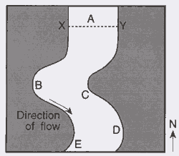
Day 8 Water chemistry: What is pH? How does it vary and what controls the values?
Activity 1 (10-15 minutes)
- pH is the measure of the acidity or alkalinity of a solution. Values range from 0 to 14, with low values defined as acidic (high hydrogen ion concentration) and high values defined as basic or alkaline (low H⁺ concentration). Natural surface waters typically have pH values near neutral (7) but volcanic waters range to values of zero – and still are full of bacteria!
- Allow students to test the pH of different solutions

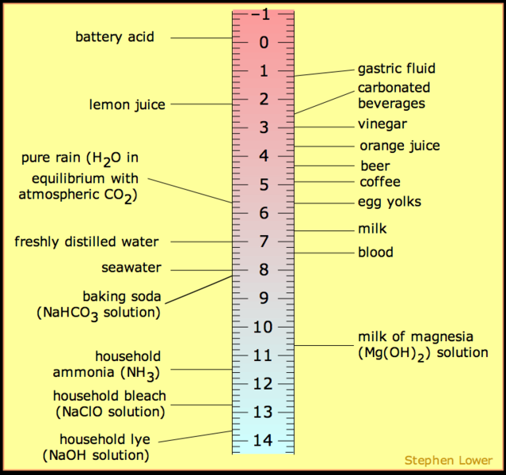

Activity 2 (25-30 minutes)
Discussion question: What factors might contribute to the pH of stream water? (key answers include the pH of precipitation and the influence of rock type, both described below)
This question depends on understanding where stream water originates, which students in urban areas tend not to grasp immediately but students in suburban and rural areas understand more readily: rainfall and melting snow supply the bulk of water that we find in streams and ponds. In Centre County there are two additional sources of water that are important: (a) springs, like Big Spring in Bellefonte and (b) water that has traveled underground in limestone caves. Both of these latter waters have high pH values relative to rain and snow. Students are likely to have heard the phrase “acid rain” – a good opportunity to mention that rainwater becomes acidified by interacting with particulate matter generated by the burning of coal (particularly sulfur particles).

Two rainfall pH maps are provided for the continental US (1994 and 2007). Students can discuss the differences between the distribution of “acid rain” both (a) over the 13 year time period and (b) across the United States. Note that low values in the eastern US are attributed to the many coal-fired power plants in the Ohio River valley region.

Once rain falls on the land and moves underground towards a stream, it interacts with rocks and soil. Rocks that have chemical ions that interact with the free hydrogen can neutralize precipitation acidity, and result in waters with neutral pH levels. Sandstone (made of quartz, SiO₂) has almost no capacity to neutralize acidity, but limestone (made of calcite, CaCO₃) has tremendous capacity for neutralization.

There are also man-made influences on water chemistry that are important in rural (e.g., farm fertilizers) and urban (e.g., pollutants) communities.

Thought question: How might the pH of an imaginary stream vary as it flows across several rock types and through a combination of rural and urban areas? (Students could draw maps – make sure that all rivers run downhill! In Centre County, that means streams start out at high elevation with low pH and reach valleys with higher pH because of the rock types; human influences are minor but can also be considered.)

Data study and discussion – Spring Creek watershed
On the following pages are two maps of the watershed. Watersheds are defined by the areas from which rainfall or subsurface water flows contribute to a particular stream – in this case, Spring Creek. Note the variations in rock type (and associated elevation) within the watershed. Some key points:
- Lithology contributes greatly to changes in water chemistry along Spring Creek
- Water quality along Spring Creek has the potential of being adversely affected because of agricultural land use along the stream, as well as the excavation of Skytop Mountain for interstate I-99 where pyrite was exposed, forming acid that entered the water system
- Spring Creek starts from a synclinal ridge made of sandstone. Sandstone cannot neutralize acid, so the pH readings show low numbers similar to rainfall values
- Further downstream flow proceeds through the valley, consisting of primarily limestone, which neutralizes the acidity making pH values more basic.
- Plot the pH values you measured on the map in the correct locations

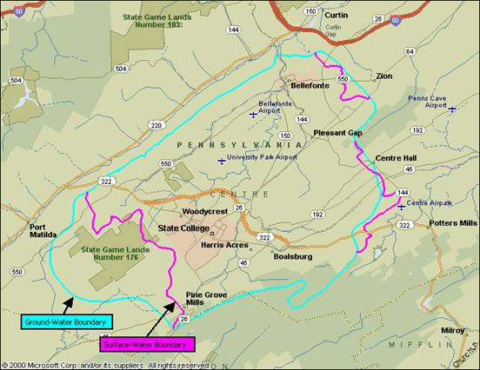

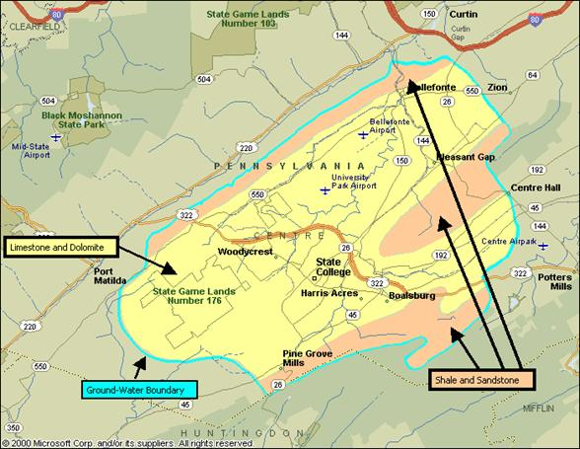

http://www.srbhos.psu.edu/srb_testbeds/springcreek.asp

Day 9 Final project preparation: Spring Creek
Activity 1 (10 minutes): Remove the blocks of sedimentary rock from the various aqueous solutions (from Day 1) and weigh them. Which rocks underwent the greatest degree of chemical weathering? Which pH levels caused the greatest amount of weathering?

Activity 2: (30-50 minutes; carry-over to Day 10)
Student teams or individuals create posters that show the following concepts as applied to the local area:
- Schematic cross-section of Centre County (or any Valley and Ridge province area) showing the effect of rock type on topography
- Predict many millions of years into the future: what will the region look like (valleys may be deeper as limestone and shale continue to erode faster, or mountains will be lower because everything will erode – either scenario is reasonable as long as it is justified)
- Trace a stream from its beginnings to a reasonable downstream location, and indicate the likely pH changes along stream. Justify these changes, which may be lithological or anthropogenic.
- These concepts could be shown on a top-view map or a cross-section, and students can choose whatever works for them.
- Additional information as creativity permits!

Day 10 Spring Creek wrap-up and post-test
Students finish their posters and take the content post-test.

